15/01/20
THM 415: Finance
Final Exam Answer Sheet
1. Explain the reason behind the fact that market value of the bond approaches its par value as the bond maturity date approaches? (2 Points)
Market value of the bond approaches its par value as the bond maturity date approaches because, at maturity date, the bond will be taken away and the investor will receive, as promised, only and only the face value (i.e. par value) of the bond.
2. The following depicts Corporate Bonds Spread Table:
Adem Corporation is considering issuing bonds that will mature in 7 years with 9.03 % annual coupon rate. The interest will be paid monthly. Adem Corporation is hoping to get an A- rating on its bonds. However Adem Corporation is not sure whether the new bonds will receive that very rating.
- What is the price of Adem Corporation bond? (1 Point)
According to the above Corporate Bonds Spread Table, the yield to maturity on A- rated 7-year bonds shall be 2.73 % + 1.61 % = 4.34 %. Hence, the price of Adem Corporation bond shall be:
- Bond Price (A- rating) = - PV (4.34%/12, 7*12, (1000*9.03%)/12, 1000) = $ 1,282.68.
- What is the price of the bond if it gets a BBB+ rating? (1 Point)
According to the above Corporate Bonds Spread Table, the yield to maturity on BBB+ rated 7-year bonds shall be 2.73 % + 1.69 % = 4.42 %. Hence, the price of Adem Corporation bond shall be:
- Bond Price (BBB+ rating) = - PV (4.42%/12, 7*12, (1000*9.03%)/12, 1000) = $ 1,277.12.
3. Karius Company’s bonds mature in 27 years time and promise to pay 6.14 % coupon interest semi-annually. Suppose you purchase the bonds for $ 923.36.
a) What is Karius Company’s promised yield to maturity? (1 Point)
- Promised Yield to Maturity = Rate (27*2, (1000 * 6.14 %) / 2, -923.36, 1000) ≈ 3.38 %.
Since this promised rate is a semi-annual rate, the promised yield to maturity shall be 3.38% * 2 = 6.76 %.
b) Assume there is a 33 % probability of default on this bond and if the bond defaults, the bondholders will receive only 70 % of the principal and interest owed. What is the expected yield to maturity on this bond? (2 Points)
In case of default, I will get only 70 % of the principle (i.e. 70 % * 1,000 = $ 700) and 70 % of the payment (i.e. 70 % * (1,000 * 6.14 %) / 2 = $ 21.49). Therefore, Yield to Maturity _{Default} = Rate (27*2, 21.49, -923.36, 700) * 2 ≈ 2.08 % * 2 = 4.16 %.
- Expected Yield to Maturity = (67 % * 6.76 %) + (33 % * 4.16 %) = 5.90 %.
4. Vasquez Corporation is considering three mutual exclusive investments. The projects’ expected net cash flows are as follows:
 | Expected Net Cash Flows
Year | Project A | Project B | Project C
0 | ($50,053) | ($25,353) | ($12,525)
1 | $9,941 | $4,528 | ($723)
2 | $14,547 | $6,723 | $5,782
3 | ($568) | $5,052 | ($339)
4 | ($963) | ($257) | $8,453
5 | $6,878 | ($903) | ($124)
6 | $10,523 | $7,742 | $7,073
7 | $14,789 | $5,683
8 | ($1,002) | $7,375
9 | $4,599 | ($1,385)
10 | $8,856 | $5,650
11 | ($105)
12 | ($237)
13 | $4,112
14 | ($1,099)
15 | $5,616
a) What is the Net Present Value of Projects A, B and C at an appropriate discount rate of 3.14%? (1.50 Point)
- NPV (Project A) = NPV (3.14%, 9941, 14547, -568, -963, 6878, 10523, 14789, -1002, 4599, 8856, -105, -237, 4112, -1099, 5616) – 50053 = $ 12,968.82.
- NPV (Project B) = NPV (3.14%, 4528, 6723, 5052, -257, -903, 7742, 5683, 7375, -1385, 5650) – 25353 = $ 8,826.80.
- NPV (Project C) = NPV (3.14%, -723, 5782, -339, 8453, -124, 7073) – 12525 = $ 5,139.24.
b) What is the Equivalent Annual Cost of Projects A, B and C? (1.50 Point)
- EAC (Project A) = PMT (3.14%, 15, -12968.82, 0) = $ 1,097.38.
- EAC (Project B) = PMT (3.14%, 10, -8,826.80, 0) = $ 1,042.18.
- EAC (Project C) = PMT (3.14%, 6, -5139.24, 0) = $ 953.10.
c) What are the Payback Periods for Project A, B and C? (1.50 Points)
- Payback Period (Project A) = 6.66 Years.
- Payback Period (Project B) = 6.43 Years.
- Payback Period (Project C) = 3.92 Years.
d) What are the MIRR’s for Project A, B and C? (3 Points)
- MIRR (Project A) = IRR (-53,155.25, 9941, 14547, 0, 0, 6878, 10523, 14789, 0, 4599, 8856, 0, 0, 4112, 0, 5616) = 7.27 %.
- MIRR (Project B) = IRR (-27402.36, .4528, 6723, 5052, 0, 0, 7742, 5683, 7375, 0, 5650) = 9.10 %.
- MIRR (Project C) = IRR (-13641.20, 0, 5782, 0, 8453, 0, 7073) = 11.84 %.
e) Based on MIRR, which project shall be chosen? Why? (1 Point)
Based only on MIRR (there are problems with rankings of the projects if we don’t use NPV though), project C shall be chosen because its MIRR (11.84 %) is at the same time greater than discount rate (3.14 %) and the highest amongst other projects (all modified projects are conventional cash flow patterns).
5. Campana Company is considering an independent project. The project’s expected net cash flows are as follows:
a) Calculate project’s IRR. (1 Point)
- IRR (Project) = IRR (-500000, 281250, 281250, 281250, 281250, 281250, -937500) = 2.68 %.
b) Draw the NPV profile for the project starting with a discount rate of 0% and increments of 2 % until you reach a discount rate of 36 %. (3 Points)
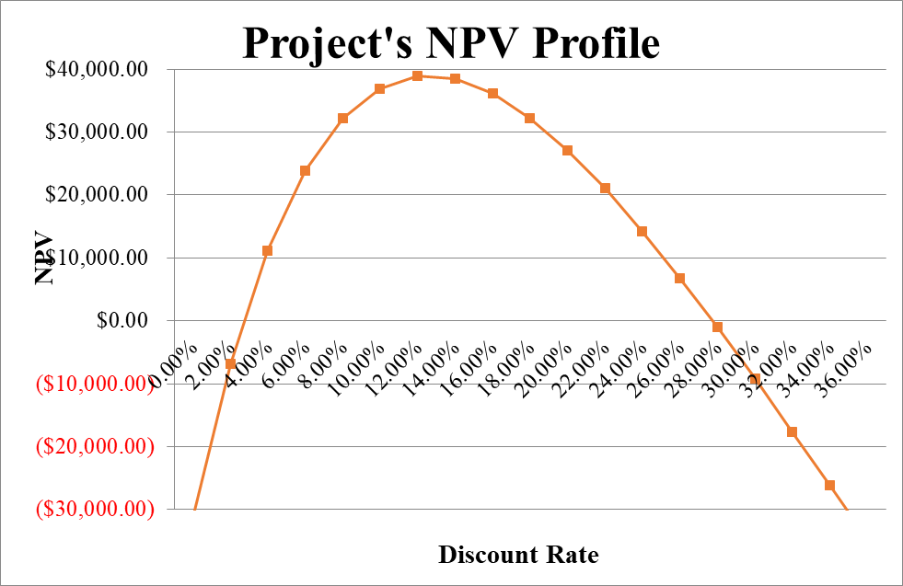
c) Referring to the NPV Profile prepared in part b), what is the second IRR of the project? (2 Points)
The second IRR of the project occurs when the discount rate used is 27.74 %.
d) What is your decision as far as to accept the project or reject it? (2 Points)
If the appropriate discount rate used to evaluate this very project is between 2.68 % and 27.74 %, accept the project. Otherwise, reject it.
6. Syrus Corporation, a firm in the 40 % marginal tax bracket with a 12.33 % required rate of return or discount rate, is considering a new project. This project involves the introduction of a new product. This project is expected to last 7 years and then, because this is somewhat of a fad product, it will be terminated. Moreover, the following bits of information are pertinent to this very new project:
- Cost of new plant and equipment: $ 5,050,000
- Shipping and installation costs: $ 425,000
Year | Units Sold
1 | 100,000
2 | 140,000
3 | 225,000
4 | 180,000
5 | 125,000
6 | 55,000
7 | 33,000
- Sales price per unit: $ 95 in year 1; expected to increase by 3 % on a yearly basis.
- Variable cost per unit: $ 42 in year1; expected to increase by 2.75 % on a yearly basis.
- Annual fixed costs: $ 2,415,000
- Working capital requirements: There will be an initial working capital requirement of $ 825,000 just to get production started. For each year, the total investment in net working capital will equal 9.03 % of the dollar value of sales for that year. In the final year, all working capital is liquidated at the termination of the project.
- The depreciation method: Use the simple straight line method over 7 years. It is assumed that the plant and equipment will have no salvage value after 7 years.
a) Determine the yearly net free cash flows associated with the project? (5 Points)
b) Sketch a timeline for this new project? (0.50 Points)
c) Calculate the Profitability Index of the project? (1 Point)
- Profitability Index = NPV (12.33 %, 2011007, 3079067, 5673072, 5515028, 3852466, 1570764, 678235) / (6300000) = 2.37 times.
d) Shall the project be undertaken? Why? Why not? (1 Point)
Since profitability index of the estimated cash flows of the project is greater than 1, Syrus Corporation shall undertake the project.
7. Erkin Company is evaluating the purchase of Caner Company. As a first step, Erkin Company wants to determine the Weighted Average Cost of Capital (WACC) (i.e. the appropriate discount rate to discount future estimated cash flows of Caner Company). In this regard, Erkin Company determined the following dollar values pertinent to the right hand-side of the balance sheet of Caner Company:
- What is the weight attributed to each source of capital? (1 Point)
First of all, not all liability and owners’ equity accounts are source of capital. We have to discard accounts payable and accrued expenses. Moreover, we have to look at market values instead of book values. In this regard, the weight attributed to each source of capital is depicted in the following table:
While short debt is entirely coming from a loan obtained from a private bank with a yearly interest rate of 8.33 %, long term debt is entirely coming from a 23-year issued bond (with 19 years to maturity) 7.14 % coupon rate and interest paid on a quarterly basis. The bond price is currently traded at $ 903.03. Lastly suppose that marginal tax rate is 34.55 %.
- What is the cost of short-term debt? (1 Point)
- Cost of short-term debt = 8.33 % *(1 – 34.55 %) = 5.45 %.
- What is the cost of long-term debt? (1 Point)
- Yield to maturity = Rate (19*4, (1000*7.14%)/4, - 903.03, 1000) * 4 = 2.04 % * 4 = 8.15 %.
- Cost of long-term debt = 8.15 % * (1 – 34.55 %) = 5.33 %.
- If preferred stocks issued by Caner Company pays 6.54 % annual dividend and those very preferred stocks are traded currently at $ 1,114.77, what is the cost of preferred stock? (1 Point)
- Preferred stock dividend = 1,000 * 6.54 % = $ 65.40.
- Cost of preferred stock = (65.40 / 1,114.77) * 100 = 5.87 %.
Suppose that caner common stockholders have received dividends (pertaining to last year) of $ 4.03 per share and that very company’s common stocks are traded currently at $ 525.04 per share. Lastly, Caner Company has paid the following dividends during the last 8 years:
- What is the cost of common stock? (1 Point)
Since geometric average takes into account the effect of compounding, it is a better measurement of the common stock growth rate.
- Growth Rate = 3.58 %
- Dividend 1 = 4.03 * (1 + 3.58 %) = $ 4.17
- Cost of common stock = (4.17 / 525.04) + 3.58 % = 4.38 %.
- What is the Weighted Average Cost of Capital (WACC) of Caner Company? (1 Point)
- Suppose Erkin Company is in need of $ 65,750,000 to finalize the acquisition of Caner Company. Moreover, the amount needed will be financed 40 % through issuance of common stock and the remaining through issuance of bonds. Lastly, the intermediary bank responsible for the financing told that issue costs associated with bonds is 7.25 % while issue costs associated with equity is 9.03 %. What is the floatation cost associated with the acquisition of Caner Company? (1 Point)
- Floatation cost of issuance of bonds = 7.25 %
- Weight of bonds in financing = 60 %
- Cost of issuance of common stock = 9.03 %
- Wight of common stocks in financing = 40 %
- Weighted average floatation cost = (60 % * 7.25 %) + (40 % * 9.03 %) = 7.96 %.
- Floatation cost associated with acquisition = 65,750,000 / (1 – 7.96 %) = $ 71,437,884.35.
Erkin Company uses Discounted Payback Period as the criterion to decide whether to finalize the purchase or not. Moreover, Erkin Company values 3 years as the cutoff period. Finally, the estimated cash flow generated from the purchase of Caner Company for the next 10 years is depicted as the following:
Year | Cash Flow
1 | $15,614,523.00
2 | $23,698,777.00
3 | $27,546,900.00
4 | $21,547,300.00
5 | $15,445,782.00
6 | ($1,903,903.00)
7 | $4,253,874.00
8 | $6,589,230.00
9 | ($750,235.00)
10 | $2,125,745.00
- Shall the acquisition be finalized? Why? Why not? (Show all necessary calculations) (2 Points)
The estimated cash flow generated from Caner Company is as follows:
Since Erkin Company uses discounted payback period to evaluate its projects, we shall calculate the discounted payback period of Caner Company (bearing in mind that discount rate is 5.11 %):
- Discounted Payback Period (Caner Company) = 3.65 Years.
→ Since discounted payback period (i.e. 3.65 Years) is greater than cutoff period (i.e. 3 years), Erkin Company shall NOT finalize the acquisition of Caner Company.
Good Luck

